**Web Accessibility Research**

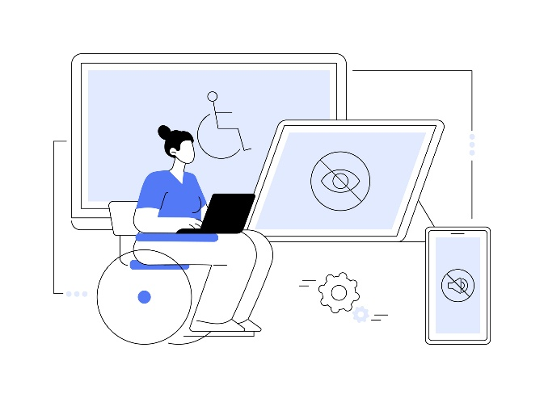Web accessibility refers to the usability of digital platforms and media by all users, including those with disabilities. It is a fundamental aspect of graphic design, especially in UI/UX design, as it promotes inclusivity. Accessible products and services ensure that users feel included and understood. When designing for accessibility, it’s important to consider different types of disabilities, whether permanent or temporary. These include visual, auditory, motor, and cognitive impairments. Keeping these in mind leads to more functional and user-friendly designs.

For users with visual impairments, such as blindness or colour blindness, proper colour contrast and font size are essential for readability. Text should stand out against the background, and fonts should be responsive to different screen sizes. Light and dark mode options helps users customise their viewing experience.

People with auditory impairments, such as those who are deaf or hard of hearing, rely on captions and transcripts to understand audio content.

Users with motor impairments, who have limited hand mobility, often struggle with mouse navigation. They benefit from keyboard shortcuts, fewer button clicks, and simple layouts that don’t require excessive interaction.

People with cognitive impairments, such as learning disabilities or attention disorders, websites should be easy to navigate with clear layouts and simple structures to help with information processing.

A good example of an accessible website is BBC News because it follows accessibility principles. It has high contrast between text and background, making it easier to read. The text size can be adjusted without breaking the layout, and the site is responsive, so it works well on different devices. It also includes transcripts and captions for videos, which help users with hearing impairments, and alt text for images, making content accessible to screen readers.

On the other hand, Reddit has several accessibility issues. The low contrast text, especially in dark mode, makes reading difficult for people with visual impairments. The site is inconsistent with alt text, since many posts rely on images without proper descriptions. The cluttered layout—especially the homepage and comment sections—can be overwhelming, with too much information and ads packed together. Many A screenshot of a black screen
interactive elements, like the upvote/downvote buttons, can be hard to use without a mouse, making it difficult for people with motor impairments.

For my final project, I’m creating a personal portfolio website that focuses on accessibility and usability. I want it to be easy to navigate, so I’ll use a well-contrasted brand colour palette, a readable font, and a simple layout without unnecessary buttons. The site will also be fully responsive, with both text and media adjusting smoothly to different screen sizes. For user experience, I’ll include light and dark mode options for better readability.

My goal is to design a clean and user-friendly portfolio that represents my brand and style while keeping the content relevant. It will be a space to showcase my graphic design work and help me connect with others in the industry. Since my design style is minimalist, I want my website to reflect that—straightforward and functional.